PEMILIHAN
package Jobsheet1;

import java.util.Scanner;

public class pemilihan {
public static void main(String[] args) {
Scanner input = new Scanner(System.in);
double[] nilai = new double[4];
String[] namaNilai = {"Tugas", "Kuis", "UTS", "UAS"};

System.out.println(
"Program Menghitung Nilai Akhir" +
"\n=============================="
);

for (int i = 0; i < nilai.length; i++) {
System.out.print("Masukkan Nilai " + namaNilai[i] + " : ");
nilai[i] = input.nextDouble();

if (nilai[i] < 0 || nilai[i] > 100) {
System.out.println("nilai tidak valid");
i--;
}
}
System.out.println("==============================");

double nilaiAkhir = (nilai[0]*0.2 + nilai[1]*0.2 + nilai[2]*0.3 + nilai[3]*0.3);
String nilaiHuruf = "";

if (80 < nilaiAkhir && nilaiAkhir <= 100) {
nilaiHuruf = "A";
} else if (73 < nilaiAkhir && nilaiAkhir <= 80) {
nilaiHuruf = "B+";
} else if (65 < nilaiAkhir && nilaiAkhir <= 73) {
nilaiHuruf = "B";
} else if (60 < nilaiAkhir && nilaiAkhir <= 65) {
nilaiHuruf = "C+";
} else if (50 < nilaiAkhir && nilaiAkhir <= 60) {
nilaiHuruf = "C";
} else if (39 < nilaiAkhir && nilaiAkhir <= 50) {
nilaiHuruf = "D";
} else if (nilaiAkhir <= 39) {
nilaiHuruf = "E";
}

System.out.println("==============================");
System.out.println("Nilai Akhir: " + nilaiAkhir);
System.out.println("Nilai Huruf: " + nilaiHuruf);
System.out.println("==============================");

if (nilaiHuruf.equals("A") || nilaiHuruf.equals("B+") || nilaiHuruf.equals("B") || nilaiHuruf.equals("C+") || nilaiHuruf.equals("C")) {
System.out.println("LULUS");
} else {
System.out.println("TIDAK LULUS");
}

input.close();
}
}
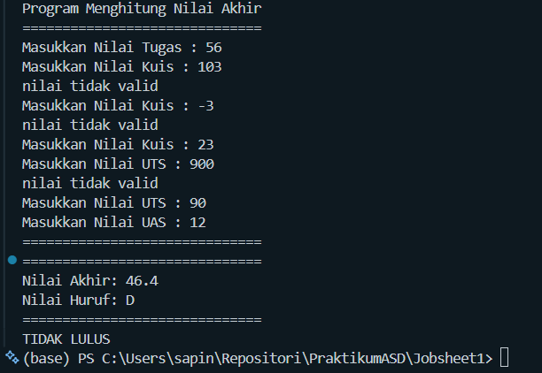
PERULANGAN
package Jobsheet1;

import java.util.Scanner;

public class perulangan {
public static void main(String[] args) {
Scanner input = new Scanner(System.in);

System.out.print("Masukkan NIM: ");
long nim = input.nextLong();

long n = nim % 100;
System.out.println("N: " + n);

for (int i = 1; i <= n; i++) {
if (i == 10 || i == 15) {
continue;
} else if (i % 3 == 0) {
System.out.print("#");
} else if (i % 2 != 0) {
System.out.print("*");
} else {
System.out.print(i);
}

System.out.print(" ");
}

input.close();
}
}
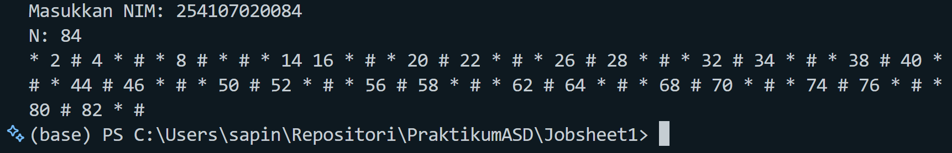

ARRAY
package Jobsheet1;

import java.util.Scanner;

public class array {
static String nilaiHuruf(double nilai) {
String nilaiHuruf = "";
if (80 < nilai && nilai <= 100) {
nilaiHuruf = "A";
} else if (73 < nilai && nilai <= 80) {
nilaiHuruf = "B+";
} else if (65 < nilai && nilai <= 73) {
nilaiHuruf = "B";
} else if (60 < nilai && nilai <= 65) {
nilaiHuruf = "C+";
} else if (50 < nilai && nilai <= 60) {
nilaiHuruf = "C";
} else if (39 < nilai && nilai <= 50) {
nilaiHuruf = "D";
} else if (nilai <= 39) {
nilaiHuruf = "E";
}

return nilaiHuruf;
}

static double nilaiSetara(String nilaiHuruf) {
double nilaiSetara = 0;
switch (nilaiHuruf) {
case "A":
nilaiSetara = 4.0;
break;
case "B+":
nilaiSetara = 3.5;
break;
case "B":
nilaiSetara = 3.0;
break;
case "C+":
nilaiSetara = 2.5;
break;
case "C":
nilaiSetara = 2.0;
break;
case "D":
nilaiSetara = 1.0;
break;
case "E":
nilaiSetara = 0.0;
break;
}
return nilaiSetara;
}
public static void main(String[] args) {
Scanner input = new Scanner(System.in);

String[] mataKuliah = new String[8];
double[] nilaiAngka = new double[mataKuliah.length];
String[] nilaiHuruf = new String[mataKuliah.length];
double[] nilaisetara = new double[mataKuliah.length];
int[] sks = new int[mataKuliah.length];

System.out.println(
"===============================" +
"\nProgram Menghitung IP Semester" +
"\n==============================="
);

for (int i = 0; i < mataKuliah.length; i++) {
System.out.print("masukkan nama Mata Kuliah ke-" + (i + 1) + ": ");
mataKuliah[i] = input.nextLine();

System.out.print("masukkan SKS untuk Mata Kuliah " + mataKuliah[i] + ": ");
sks[i] = input.nextInt();
input.nextLine();
}

System.out.println(
"===============================" +
"\nMasukkan Nilai Angka" +
"\n==============================="
);

for (int i = 0; i < mataKuliah.length; i++) {
System.out.print("masukkan nilai Angka untuk Mata Kuliah " + mataKuliah[i] + ": ");
nilaiAngka[i] = input.nextDouble();
input.nextLine();

if (nilaiAngka[i] < 0 || nilaiAngka[i] > 100) {
System.out.println("nilai tidak valid");
i--;
continue;
}
nilaiHuruf[i] = nilaiHuruf(nilaiAngka[i]);
nilaisetara[i] = nilaiSetara(nilaiHuruf[i]);
}

System.out.println(
"===============================" +
"\nHasil Konversi Nilai" +
"\n==============================="
);

System.out.printf(
"%-38s %-12s %-14s %-10s\n", "Mata Kuliah", "Nilai Angka", "Nilai Huruf", "Bobot Nilai" +
"\n========================================================================================="
);

for (int i = 0; i < mataKuliah.length; i++) {
System.out.printf("%-40s %-14.2f %-14s %-12.2f\n", mataKuliah[i], nilaiAngka[i], nilaiHuruf[i], nilaisetara[i]);

}

double totalskor = 0;
double totalSKS = 0;

for (int i = 0; i < mataKuliah.length; i++) {
totalskor += nilaisetara[i] * sks[i];
totalSKS += sks[i];
}

double ip = totalskor/totalSKS;

System.out.println("=========================================================================================");
System.out.printf("IP : %.2f", ip);

input.close();
}
}

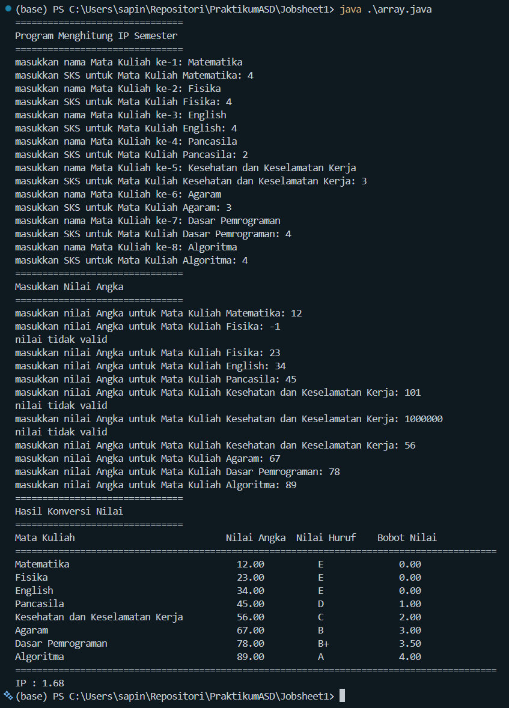
FUNGSI
package Jobsheet1;

public class fungsi {
static int[][] bunga = {
{10, 5, 15, 7},
{6, 11, 9, 12},
{2, 10, 10, 5},
{5, 7, 12, 9}
};
static int[] harga = {75000, 50000, 60000, 10000};
static int[] pendapatan = new int[4];

static void pendapatan() {
for (int i = 0; i < bunga.length; i++) {
for (int j = 0; j < bunga[i].length; j++) {
pendapatan[i] += (bunga[i][j] * harga[j]);
}
}
}
public static void main(String[] args) {
pendapatan();

System.out.println("Royal Garden\n======================");

for (int i = 0; i < bunga.length; i++) {
System.out.println("Toko Bunga ke-" + (i+1) + " : " + pendapatan[i]);
System.out.print("Status : ");

if (pendapatan[i] > 1500000) {
System.out.println("Sangat baik");
} else {
System.out.println("Perlu Evaluasi");
}
System.out.println();
}
}
}
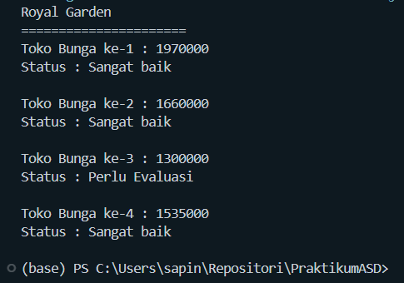

TUGAS 1
package Jobsheet1.tugas;

import java.util.Scanner;

public class soal1 {
public static void main(String[] args) {
Scanner input = new Scanner(System.in);
char[] kode = {'A', 'B', 'D', 'E', 'F', 'G', 'H', 'L', 'N', 'T'};
char[][] kota = {
{'B', 'A', 'N', 'T', 'E', 'N'},
{'J', 'A', 'K', 'A', 'R', 'T', 'A'},
{'B', 'A', 'N', 'D', 'U', 'N', 'G'},
{'C', 'I', 'R', 'E', 'B', 'O', 'N'},
{'B', 'O', 'G', 'O', 'R'},
{'P', 'E', 'K', 'A', 'L', 'O', 'N', 'G', 'A', 'A', 'N'},
{'S', 'E', 'M', 'A', 'R', 'A', 'N', 'G'},
{'S', 'U', 'R', 'A', 'B', 'A', 'Y', 'A'},
{'M', 'A', 'L', 'A', 'N', 'G'},
{'T', 'E', 'G', 'A', 'L'}
};

while (true) {
System.out.print("Masukkan KODE plat nomor (0 untuk keluar): ");
char inputKode = input.nextLine().toUpperCase().charAt(0);
boolean ada = false;

if (inputKode == '0') {
System.out.println("Program selesai.");
break;
}

for (int i = 0; i < kode.length; i++) {
if (inputKode == kode[i]) {
System.out.print("Kota : ");
for (int j = 0; j < kota[i].length; j++) {
System.out.print(kota[i][j]);
}
System.out.println();
ada = true;
break;
}
ada = false;
}
if (!ada) {
System.out.println("Kode tidak ditemukan");
}

}
input.close();
}
}
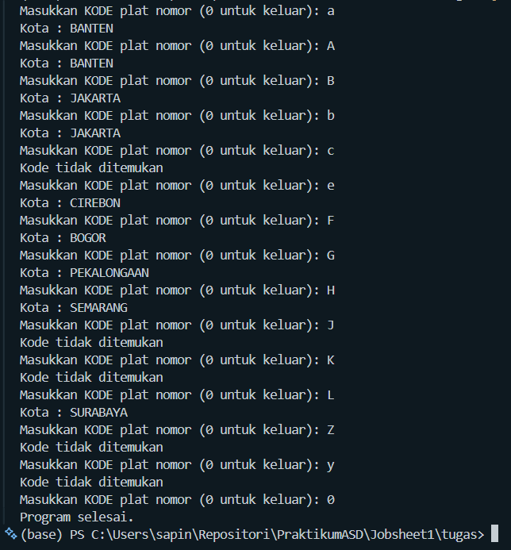
TUGAS 2
package Jobsheet1.tugas;

import java.util.Scanner;

public class soal2 {
static Scanner input = new Scanner(System.in);

static void inputJadwal(String[][] jadwal) {
for (int i = 0; i < jadwal.length; i++) {
System.out.println("Jadwal ke-" + (i + 1));
System.out.print("Masukkan Mata Kuliah: ");
jadwal[i][0] = input.nextLine();
System.out.print("Masukkan Ruangan: ");
jadwal[i][1] = input.nextLine();
System.out.print("Masukkan Hari: ");
jadwal[i][2] = input.nextLine();
System.out.print("Masukkan Waktu: ");
jadwal[i][3] = input.nextLine();
}
}

static void tampilkanJadwal(String[][] jadwal) {
if (jadwal[0][0] == null) {
System.out.println("Jadwal masih kosong");
return;
}
for (int i = 0; i < jadwal.length; i++) {
System.out.println("-----------------------");
System.out.println("Jadwal ke-" + (i + 1));
System.out.println("Mata Kuliah: " + jadwal[i][0]);
System.out.println("Ruangan: " + jadwal[i][1]);
System.out.println("Hari: " + jadwal[i][2]);
System.out.println("Waktu: " + jadwal[i][3]);
System.out.println("-----------------------");
}
}

static void cariJadwal(String[][] jadwal, int kolom) {
if (jadwal[0][0] == null) {
System.out.println("Jadwal masih kosong");
return;
}
System.out.print("Masukkan yang ingin dicari: ");
String nilai = input.nextLine();
boolean ditemukan = false;
for (int i = 0; i < jadwal.length; i++) {
if (jadwal[i][kolom].equalsIgnoreCase(nilai)) {
System.out.println("-----------------------");
System.out.println("Mata Kuliah: " + jadwal[i][0]);
System.out.println("Ruangan: " + jadwal[i][1]);
System.out.println("Hari: " + jadwal[i][2]);
System.out.println("Waktu: " + jadwal[i][3]);
System.out.println("-----------------------");
ditemukan = true;
}
}
if (!ditemukan) {
System.out.println("Jadwal tidak ditemukan");
}
}

public static void main(String[] args) {
System.out.println("Jadwal Kuliah Mahasiswa");
System.out.print("Masukkan jumlah jadwal kuliah : ");
int n = input.nextInt();
input.nextLine();

String[][] jadwal = new String[n][4];

while (true) {
System.out.println("=======================");
System.out.println("Pilih menu berikut:");
System.out.println("1. Input Jadwal");
System.out.println("2. Tampilkan Seluruh Jadwal");
System.out.println("3. Cari Jadwal Berdasarkan Hari");
System.out.println("4. cari jadwal berdasarkan mata kuliah");
System.out.println("5. Keluar");
System.out.print("Pilihan Anda: ");
int pilihan = input.nextInt();
input.nextLine();

System.out.println("=======================");
switch (pilihan) {
case 1:
inputJadwal(jadwal);
break;
case 2:
tampilkanJadwal(jadwal);
break;
case 3:
cariJadwal(jadwal, 2);
break;
case 4:
cariJadwal(jadwal, 0);
break;
case 5:
System.out.println("Keluar dari program.");
return;
default:
System.out.println("Pilihan tidak valid.");
}
}
}}
